**N  Global Warming**

Time Limit:1000MS  Memory Limit:65535K

题型: 编程题   语言: 无限制

**描述**

Global warming is a big problem, isn't it? It is reported that the ice of Antarctica is melting. It results that oceans are glowing

and more and more places are flooded. Now the city of CODE and the city of ACM are in front of the problem though no wather seperate

the two cities. The situation will change with the ice continue melting. It is reported that the oceans glow P cm per year. The mayors

of the two cities want to know how many yeas there is before the two cities are seperated by water.

The map can be descriped as following

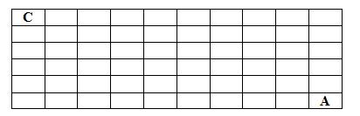

It is a M*N blocks

The city of CODE locates in the block of coordinate(1,1), the city of ACM locates in the block of coordinate(M,N). The altitude of

every blocks are given. It is guaranteed that the block of (1,1) and the block of (M,N) is higher than their neighbor block.

The following map shows the two cities weren't seperated by water.

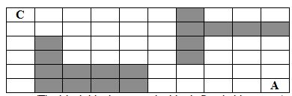

The following map shows the two cities are eperated by water.

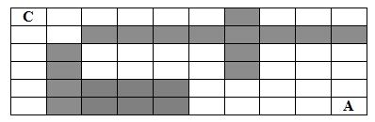

**输入格式**

The first line contains the two integer numbers N (1 <= N <= 500), M (1 <= M <= 500). Then N lines are following.

Each line contains

M integer numbers(seperated by a space). Each number no more than 1,000,000,000). The last line contains the integer number

P (1 <= P <= 1,000,000,000)

**输出格式**

The only line of the output contains the years mentioned above.

**输入样例**

3 3

9 5 7

4 6 8

8 3 9

1

**输出样例**

6

**Provider**

admin